# Apply filters to SQL queries

## Project description

In this assignment I am demonstrating how to filter SQL queries to obtain specific information from a database.

## Retrieve after hours failed login attempts

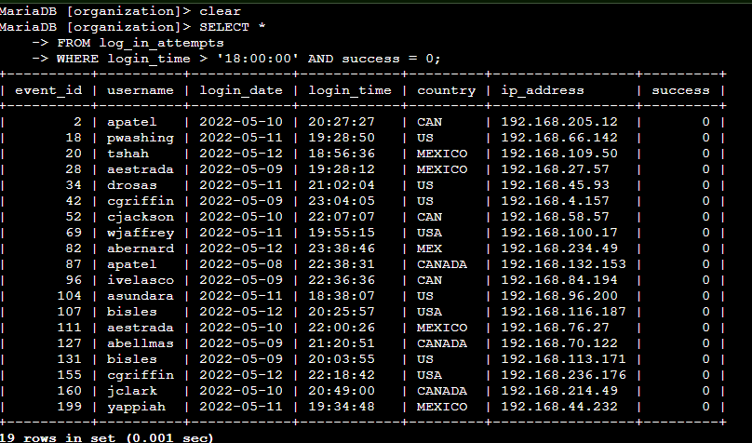

In this question I am asked to retrieve the failed login attempts from the database that occurred after 6PM in the evening. It is important to note that SQL views time in 24 hour notation hence the ‘ 18:00:00’. What is also important to note is the Boolean operator in the success column. In SQL 0 is seen as a negative identifier and 1 is seen as a positive identifier.

## Retrieve login attempts on specific dates

In this question I am asked to retrieve all login attempts made on two specific dates. To achieve this I used the following query in the screenshot:

## Retrieve login attempts outside of Mexico

The query I built for this request had to use the LIKE operator as it is understood that ‘Mexico’ in the Country column is displayed as either ‘Mex’ or ‘Mexico’. I used the percentage sign as a wildcard to ensure I received all relevant results.

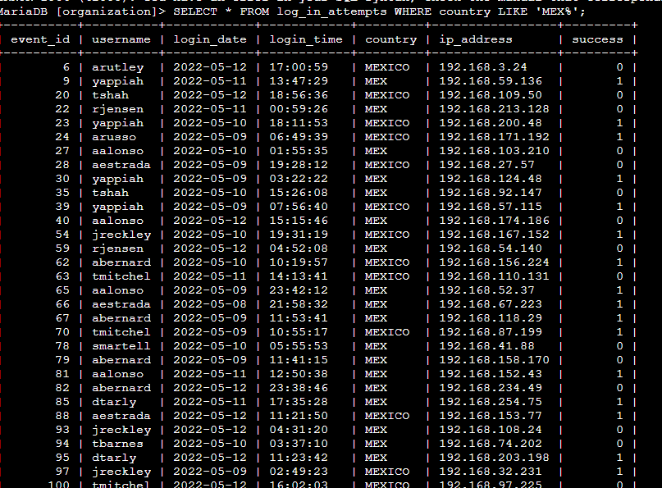

## Retrieve employees in Marketing

For this question I was asked to build a query displaying all the marketing members in the East Building as these computers were due for updates. As done previously I used the like operator to give me the all the machines in the office area ‘East’ and a stipulation in the query to only give me those in the marketing department:

## Retrieve employees in Finance or Sales

For this Query I was asked to retrieve information regarding all employees in the Sales or Finance departments. I used an OR operator to indicate that both departments were required:

## Retrieve all employees not in IT

For this query, I was asked not to include the Information Technology Department. I could have used a ‘NOT’ operator. I chose however to use the ‘!=’ operator which denotes to not equal to.

## Summary

I applied SQL filters to two different tables ‘log_in_attempts’ and ‘employees’. Using different operators such as ‘AND’, ‘OR’ , ‘NOT’ and ‘LIKE’ along with wildcards such as ‘%’ to obtain the correct information.